Project Design Phase-II
Data Flow Diagram & User Stories
Date | 14 July 2026
Team ID | SWTID-2026-5258
Project Name | India's Agricultural Crop Production Analysis (1997–2021)
Maximum Marks | 4 Marks

Data Flow Diagrams:
The Agricultural Crop Production Dashboard collects crop data from the Excel dataset, cleans and processes it, calculates KPIs, and presents interactive visualizations to farmers, researchers, government officers, and administrators. The diagrams below show how data moves through the system at Level-0 (overview) and Level-1 (detailed process breakdown).
Level-0 DFD (Context Level)
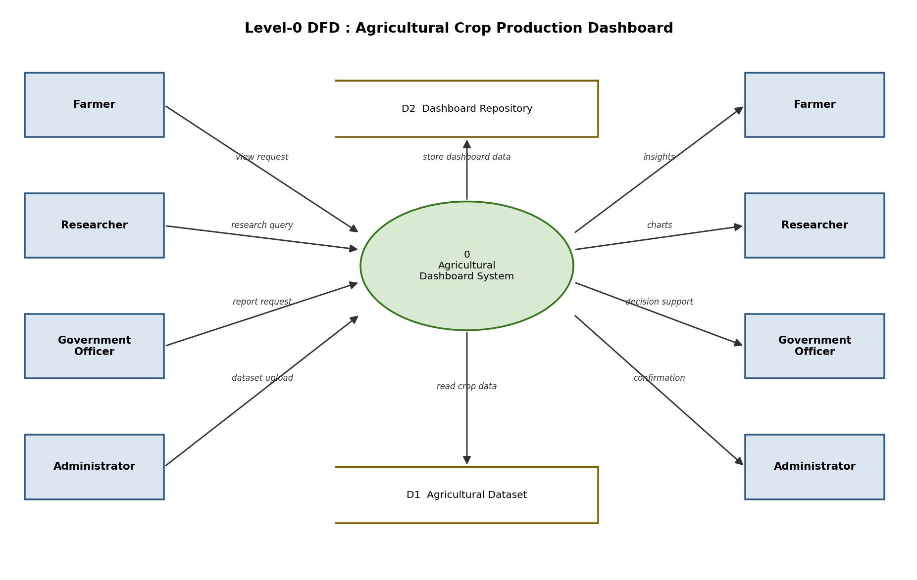

Level-1 DFD (Detailed Process Breakdown)
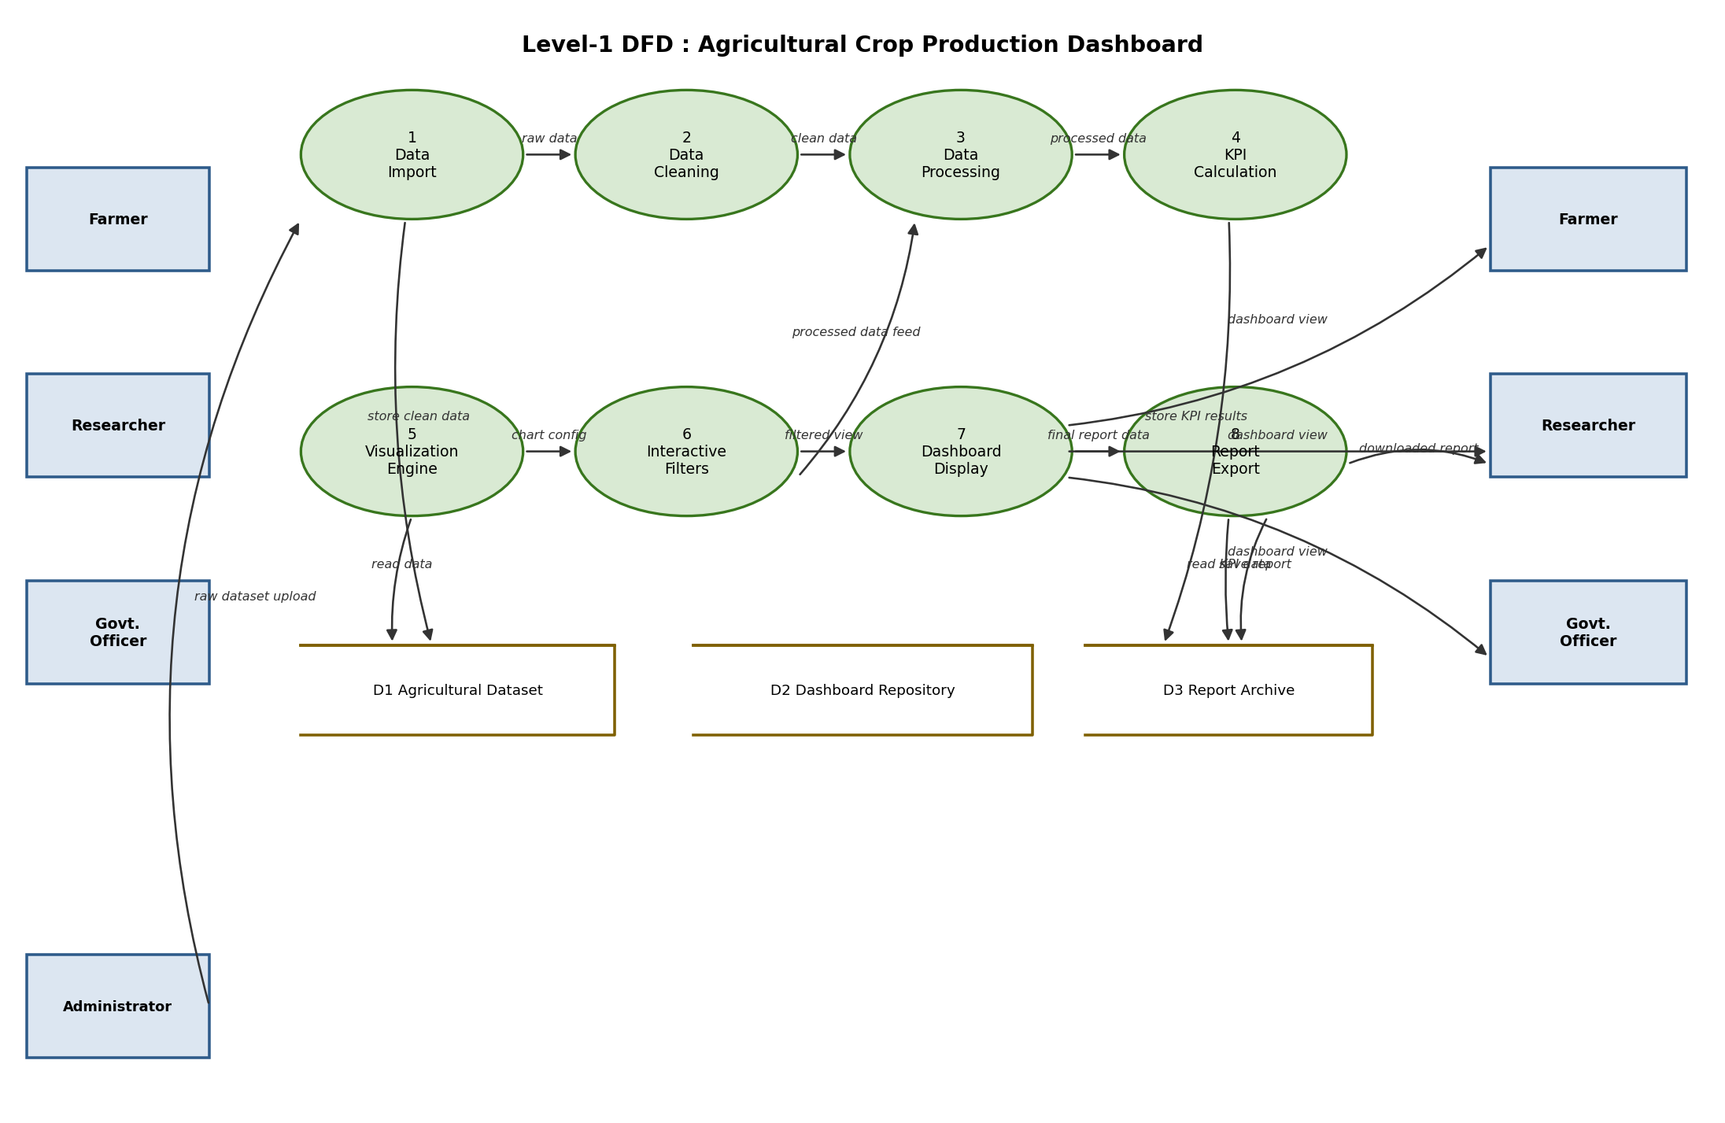

User Stories
The table below lists the user stories for the Agricultural Crop Production Dashboard, covering all major user types and their expected interactions with the system.
User Type | Functional Requirement (Epic) | User Story Number | User Story / Task | Acceptance Criteria | Priority | Release
Farmer (Dashboard user) | Login | US-1 | As a farmer, I can access the dashboard directly through a public link without creating an account. | I can open the dashboard link and view the home screen without login errors. | High | Sprint-1
Farmer (Dashboard user) | View Dashboard | US-2 | As a farmer, I can view the full dashboard with all KPIs and charts as soon as it loads. | I can see KPI cards and charts populated with data on the first screen. | High | Sprint-1
Farmer (Dashboard user) | State Filter | US-3 | As a farmer, I can select my state so that I only see data relevant to my region. | Selecting a state updates the map and all charts to that state only. | High | Sprint-1
Farmer (Dashboard user) | Crop Filter | US-4 | As a farmer, I can select my crop so that I can study production trends of that crop. | Selecting a crop updates all charts to show data for that crop only. | High | Sprint-1
Farmer / Researcher | Year Filter | US-5 | As a user, I can select a year or year range to see production data for that period. | Selecting a year range updates the trend chart and KPI values accordingly. | Medium | Sprint-1
Researcher | Compare Production | US-6 | As a researcher, I can compare production of my state against other leading states. | The leading states chart highlights my selected state among the top states. | Medium | Sprint-2
Researcher / Govt. Officer | Analyze Yield | US-7 | As a researcher, I can analyze yield trends across seasons and years for any crop. | The yield chart updates correctly for the chosen crop, season, and year. | Medium | Sprint-2
Government Officer | Download Report | US-8 | As a government officer, I can download a summary report of the filtered dashboard view. | A report file is generated and downloaded matching the current filters. | Low | Sprint-2
Farmer / Researcher / Officer | Filter Dashboard | US-9 | As a user, I can apply multiple filters together so remaining charts update instantly. | Selecting one chart or filter updates all other visualizations on the dashboard. | High | Sprint-1
Administrator | Upload Dataset | US-10 | As an administrator, I can upload an updated crop dataset so the dashboard stays current. | The uploaded file replaces the old dataset and all visuals refresh with new data. | Medium | Sprint-2

